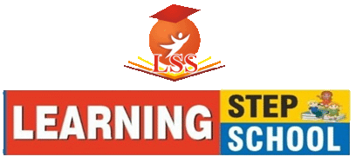
CLASS - KG
Syllabus for PT-1 (Periodic Test -1)
SESSION : (2022-23)

ENGLISH (ORAL) | *Recitation of Alphabets (A-Z) using phonics.  *Vowels and Consonants using phonics.  *Reading of sound words (a, e, i).  *Introduce Yourself from Rhymes Book.  *Recitation of book rhymes with action & expression (Teddy Bear, After A Bath & Jack & Jill).
ENGLISH (WRITTEN) | *Alphabets (A-Z).  *Small cursive alphabets (a-z) using phonics.  *Vowel and Consonants.  *Sound Words of a, e.  *Missing alphabets.  *Match the small cursive letter with the related picture or same capital letter.  *Match the word with the related picture.  *Look at each picture and write first letter.  *Dictation.
MATHS (ORAL) | *Counting (1 to 100).  *Pg. No. -3 to 26 (From Book).  *Numbers Name (1 to 5)  *Tables (0 & 1).
MATHS (WRITTEN) | *Counting (1 to 70).  *Pg. No. -3 to 25 (From Book).  *Missing Numbers.  *Count & write.  *What comes after and between?  *Numbers Name (1 to 5)  *Tables (0 to 1).  *Number Dictation.
HINDI (ORAL) | *स्वर, व्यंजन।  *दो व तीन अक्षर के शब्द।  *प्रतिक्रिया और भाव के साथ हिंदी कविताएं  (जब भी बोलो, हाथी राजा और सड़क)
HINDI (WRITTEN) | *स्वर, व्यंजन।  *चित्र का सही अक्षर से मिलान करो।  *दो अक्षर के शब्द लिखो।  *चित्र देखकर अक्षर लिखो।  *खाली जगह भरो।  *बाद में आने वाला अक्षर लिखो।  *श्रुतलेख ।
EVS (ORAL/WRITTEN) | *Fruits.  *Vegetables.  *Flowers.  *Birds.  *Animals.  *Conversation Questions from the given sheet.
Drawing | Colouring the Objects (Pg No. - 2 to 8).

