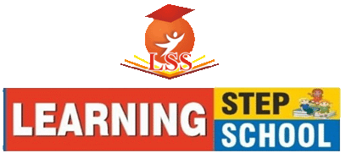
CLASS - NURSERY
Syllabus for PT-1 (Periodic Test -1)
SESSION : (2022-23)

ENGLISH (ORAL) | *Recitation of Alphabets (A to Z) using phonics.  *Recitation of About Myself from Rhymes Book.  *Recitation of Book Rhymes with action & expression  (God Bless Me & Humpty Dumpty).
ENGLISH (WRITTEN) | *Alphabets with standing, sleeping and slanting lines.(L,I,H,E,F,T,A,K,M,N,X,Y,Z).  *Look at each picture and write correct first letter.  *Write the missing letters.  *Match the letter with the related picture.  *Matching of same alphabet.  *Alphabet Dictation.
MATHS (ORAL) | *Counting (1-50).  *Count the given objects.  *Recitation of number rhymes.
MATHS (WRITTEN) | *Counting (1 – 30).  *Count the given objects & write their number.  *What comes after and between?  *Missing Numbers  *Matching of same number.  *Number Dictation.
HINDI (ORAL) | *स्वर, व्यंजन।  *प्रतिक्रिया और भाव के साथ हिंदी कविताएं ( (विनती, आज सोमवार है और गुड़िया रानी।)
HINDI (WRITTEN) | *स्वर (अ, आ, उ, ऊ, ओ, औ, अं और अः)।  *चित्र देखकर प्रथम सही अक्षर लिखो।  *चित्र देखकर सही अक्षर से मिलान करो।  *बाद में आने वाला अक्षर लिखो।  *खाली जगह भरो।  *समान अक्षरों का मिलान करो।  *श्रुतलेख
EVS (ORAL) | *Fruits Name.  *Vegetables Name.  *Flowers Name  *Conversation Questions from the given sheet.
Drawing | Colouring the Objects (Pg No. - 2 to 8)

