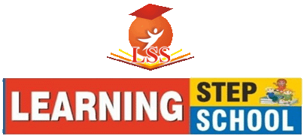
CLASS - PLAY GROUP
Syllabus for Month
April, May, June & July
SESSION : (2022-23)

English:-
Oral: - Recitation of Alphabets (A to Z) using phonics.
Recitation of book rhymes with action & expression (Early To Bed, Prayer, I See The Moon, Make New Friends & Me).

Written: - Pattern Writing (Standing, Sleeping and Slanting Lines, Semi Circle and Circle).
Pattern Writing (Alphabets with Standing, Sleeping and Slanting lines (L, T, H, I, F, E, N & K).

Math: -
Oral: - Numbers from 1 to 20.
Recitation of number rhymes.
Count the given objects.

Written: - Tracing of Lines, Curves and Numbers 1, 2, 3 & 4.
Match the number with similar number.

Hindi: -
Oral:- स्वर, व्यंजन।
प्रतिक्रिया और भाव के साथ हिंदी कविताएं (प्रार्थना, भारत देश, छाता, गुब्बारे वाला व माँ) ।

Written: - पैटर्न लेखन (खड़ी, आड़ी, तिरछी रेखाएं व वक्र)।
स्वर लेखन (उ, ऊ, अ व आ)।
चित्र का अक्षर से मिलान करो।

EVS:-
Oral:- Name of (Body Parts, Fruits, Vegetables & Flowers).
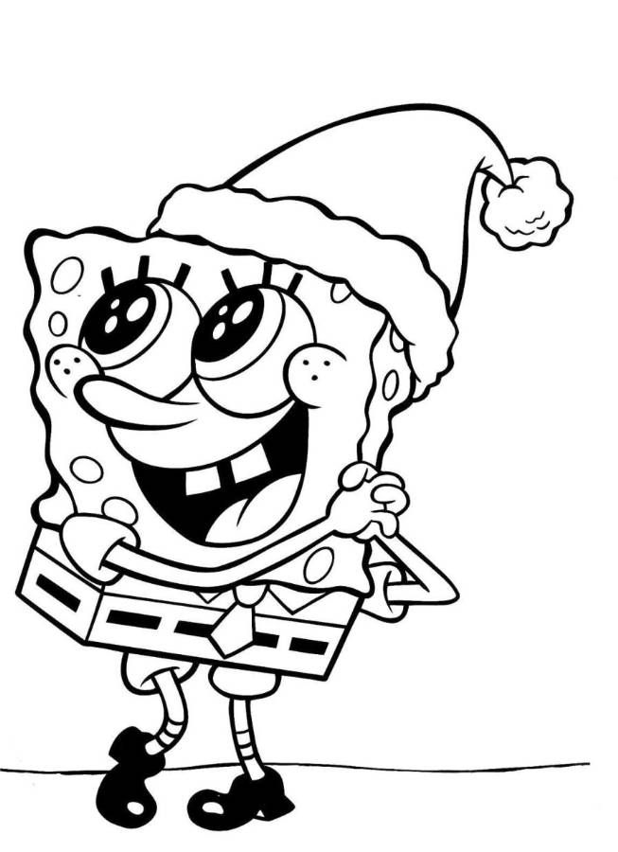
Conversation Questions about Myself.

Drawing and Motor Skills: -
Identification of different shapes Circle, Triangle, Square, Rectangle & Star.
Identification, tracing and colouring of different objects.
Colouring Pg. No. -105 & 106.

CLASS - PLAY GROUP
Syllabus for Month
August, September, October & November
SESSION : (2022-23)

English:-
Oral: - Recitation of Alphabets (A to Z) with phonics.
Recitation of book rhymes with action & expression (Little Robin, I Love You, Butterfly, To Market & Work While You Work).
Story Reading with action & expression (The Rabbit and the Tortoise – Pg. No. 46).

Written: - Tracing of Alphabets (A – H).
Match the alphabet with similar alphabet.
Match the alphabet with the related picture.
See the picture and circle the correct first alphabet.

Math: -
Oral: - Numbers from 1 to 30.
Count the given objects.
Recitation of number rhymes.

Written: - Tracing of numbers 1 to 10.
Match the number with similar number.
Count the given objects and write the number.
Missing Numbers (1 to 10).

Hindi: -
Oral: - स्वर, व्यंजन।
प्रतिक्रिया और भाव के साथ हिंदी कविताएं (मोर, सीख, बिटिया रानी, कंप्यूटर, झंडा) ।
प्रतिक्रिया और भाव के साथ हिंदी कविताएं (लालची कुत्ता – पेज नं – 94)।

Written: - स्वर लेखन (अ, आ, ओ, औ, अं व अः)।
चित्र का अक्षर से मिलान करो।
चित्र देखकर पहला अक्षर लिखो।

EVS:-
Oral:- Name of (Domestic & Pet Animals, Wild Animals, Birds & Means of Transport). Conversation Questions about My Family.
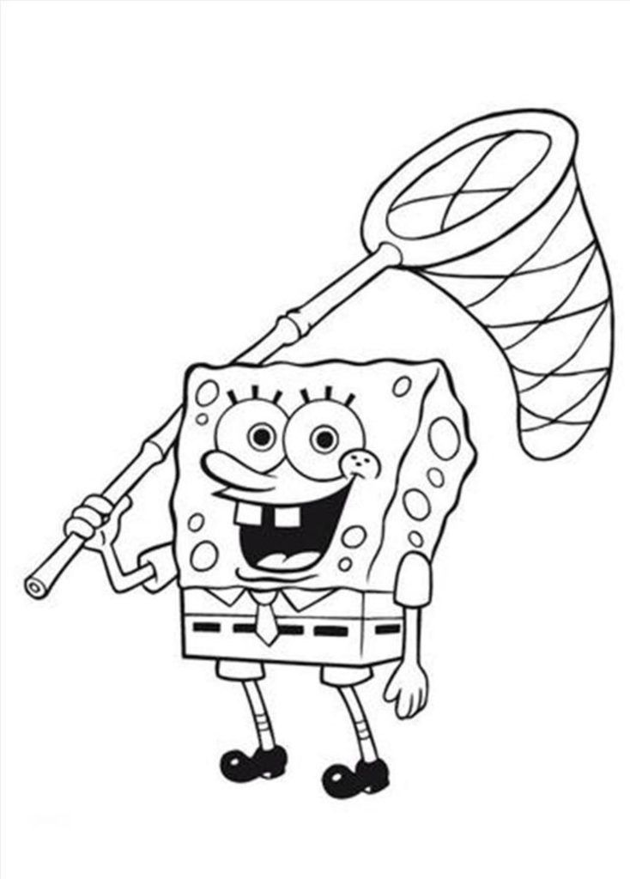
Conversation Questions (Parts of our body, Fruits & Vegetables).

Drawing and Motor Skills: -
Identification of different colours Green, Orange and White.
Tracing of different shapes and colouring.
Colouring Pg. No. -107 to 109.

CLASS - PLAY GROUP
Syllabus for Month
December, January, February & March
SESSION : (2022-23)

English:-
Oral: - Recitation of alphabets (A to Z) with phonics.
Recitation of book rhymes with action & expression ( (One Two, Round And Round, Peter Peter, Rain Rain & Ding-Dong Bell).
Story Reading with action & expression (The Thirsty Crow – Pg. No. 47)

Written: - Tracing of Alphabets (I – P).
Match the alphabet with similar alphabet.
Match the alphabet with related picture.
See the picture and circle the correct first alphabet.

Math: -
Oral: - Numbers from 1 to 50.
Count the given objects.
Recitation of number rhymes.

Written: - Tracing of numbers 1 to 20.
Count the given objects and write the number.
Match the number with similar number.
Missing Numbers (1 to 20).

Hindi: -
Oral: - स्वर, व्यंजन।
प्रतिक्रिया और भाव के साथ हिंदी कविताएं (घटा, भालू, मोटूराम, झूला, डाकिया व बत्ती)।
प्रतिक्रिया और भाव के साथ हिंदी कविताएं (शेर और चूहा – पेज नं – 95)।

Written: - स्वर लेखन (अ से अः)।
चित्र का सही अक्षर से मिलान करो।
चित्र देखकर पहला अक्षर लिखो।

EVS:-
Oral: - Name of (Cartoon Characters, Colours, Shapes, Our Helpers Good habits, Seasons & Animals Sound).
Conversation Questions about My School
Conversation Questions (Festivals & Animals).

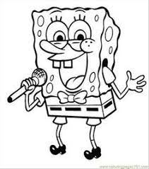
Drawing and Motor Skills: -
Identification of different colours Red, Yellow, Blue, Pink, Black and Green.
Colouring Pg No. -110 to 112.

